CSA1708-ARTIFICIAL INTELLIGENCE
LAB EXPERIMENTS
Program 6 : Python Program for the Vacuum Cleaner Problem
Aim
To write a Python program for a vacuum cleaner agent that cleans two rooms based on their condition.
Algorithm
1. Read the condition of rooms A and B and the starting location of the vacuum.
2. Check the current room. If it is dirty, clean it.
3. Move to the other room and clean it if needed.
4. Display the final condition of both rooms.
Program
rooms = {
"A": input("Condition of Room A (dirty/clean): ").lower(),
"B": input("Condition of Room B (dirty/clean): ").lower()
}
location = input("Starting room (A/B): ").upper()
other = "B" if location == "A" else "A"

for room in (location, other):
if rooms[room] == "dirty":
print("Cleaning Room", room)
rooms[room] = "clean"
else:
print("Room", room, "is already clean")

print(f"Final condition: A={rooms['A']}, B={rooms['B']}")
Sample Input
Room A: dirty Room B: dirty Starting room: A
Program Execution
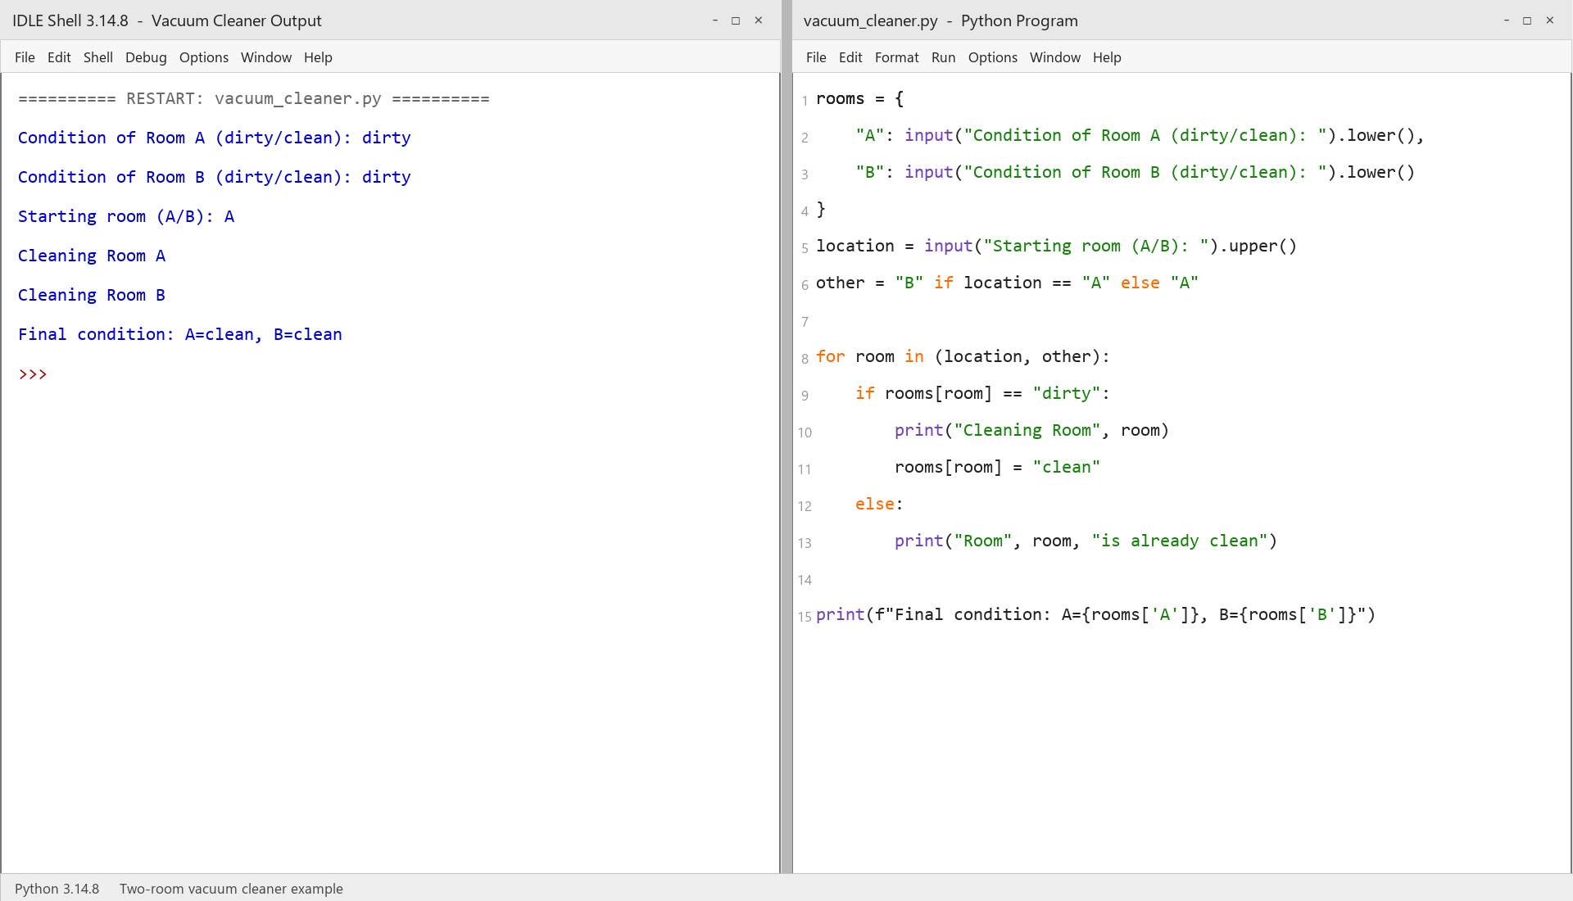
RESULT
Thus, the Vacuum Cleaner problem was implemented successfully using Python.

